Splunk SIEM Investigation: Suspicious Authentication Activity

Name: Bapanapalli Rohanteja

Aim:
"To utilize a SIEM solution (Splunk) for monitoring and analyzing simulated security alerts in order to detect suspicious activities, classify incidents, and recommend mitigation strategies based on log analysis from simulated brute force and account compromise scenarios..

Tools Used:
- SIEM Tool: Splunk Free Trial
- Environment: Windows Event Logs (custom generated)
- File: brute_force_pattern_logs.txt

Procedure s Findings: A custom Windows log file containing simulated security events was uploaded into Splunk.. Log analysis was conducted focusing on three main event types:
- 4625: Failed login attempts
- 4624: Successful login
- 4634: Logoff event
Splunk queries were used to identify brute force patterns and track successful compromises following repeated failures. A critical incident was detected: multiple failed logins to the administrator account from a single IP, followed by a successful login from the same source — indicating a brute force success.

Incident Classification:
Type Description Severity
Brute Force Attack Multiple failed login attempts from same IP High

Account Compromise
Successful login after failed attempts (admin) Critical

Recon Activity Attempts on non-existent accounts like guest Medium

Splunk Queries Used:
- Search for Failed Logons:

index=* source="brute_force_pattern_logs.txt" EventCode=4625
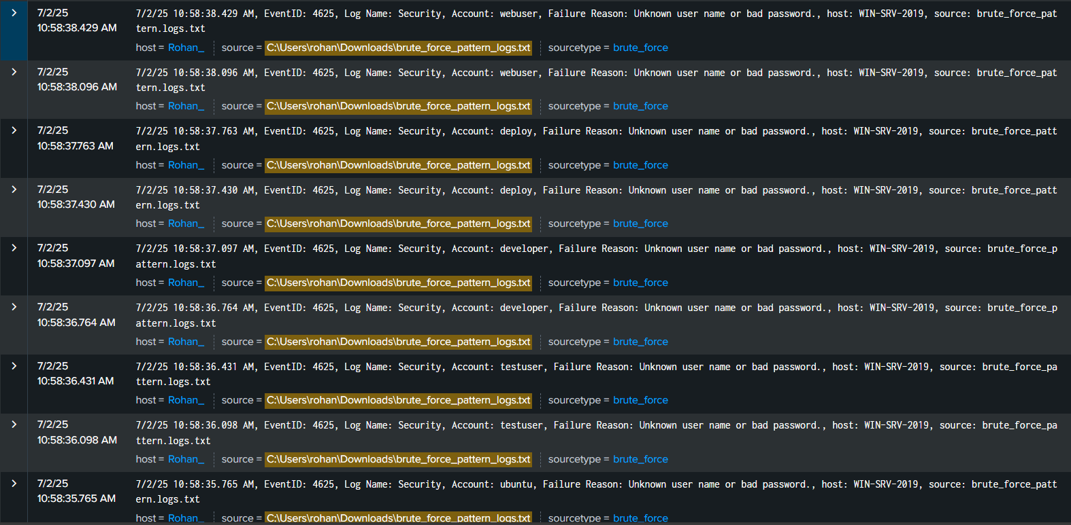

- Search for Successful Logons:
index=* source="brute_force_pattern_logs.txt" EventCode=4624
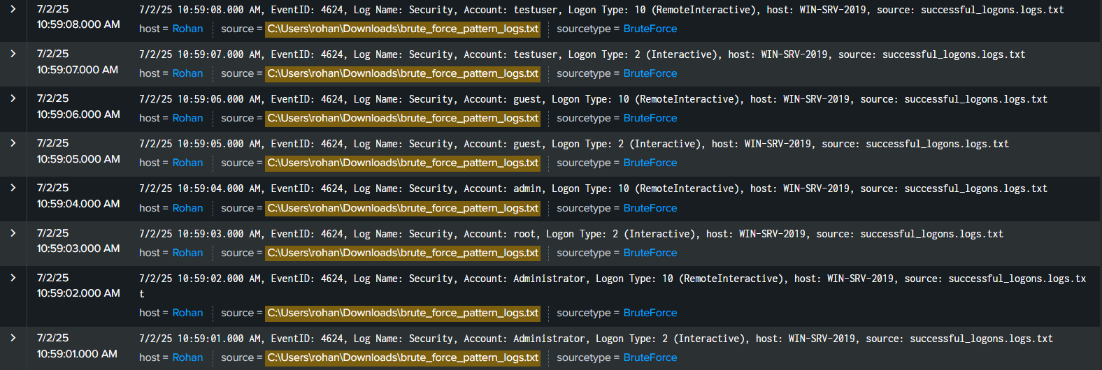
- Failed Logons by Account:
index=* source="brute_force_pattern_logs.txt" EventCode=4625
| stats count by Account
| sort -count
- IP Addresses with Multiple Failures:
index=* source="brute_force_pattern_logs.txt" EventCode=4625
| stats count by "IP Address", Account
| sort -count
- Accounts with Failures and a Success:
(index=* source="brute_force_pattern_logs.txt") (EventCode=4624 OR EventCode= 4625)
| stats values(EventCode) as event_codes by Account, "IP Address"
| where mvcount(event_codes)=2 AND "4625" IN event_codes AND "4624" IN event_ codes
- Events for Specific Account:
index=* source="brute_force_pattern_logs.txt" Account="administrator"

Security Recommendations:
  - Immediate:
o Block or monitor IPs 192.168.1.100, 192.168.1.101
    - Reset affected user passwords
    - Enforce MFA for admin-level users

Preventive:
    - Implement account lockout policies
    - Enable CAPTCHA and login rate limiting
    - Use detection rules for excessive 4625 events

Review:
    - Audit administrator logon patterns
    - Tweak Splunk alert logic for brute force detection
    - Educate users and SOC staff on recognizing these attacks

Learning Outcomes:
  - Gained understanding of Windows Event Log structure and significance
  - Learned to identify brute force and post-compromise patterns using Splunk
  - Acquired hands-on experience with SIEM queries, log correlation, and alert workflows

Ethical Note:
All experiments were conducted in a controlled lab environment using simulated security logs and ethical tools. No production systems or real users were affected.

Conclusion: This exercise successfully demonstrated how Splunk SIEM can be leveraged to monitor, detect, and classify brute force attacks and subsequent compromises. The findings highlight the importance of log correlation, pattern-based detection, and automated querying in strengthening real-world incident detection and response capabilities.

